**Bulk Export and Import**

**Bulk Export**

Before you can import VDNs in SMGR, you need to do a bulk export. Import could not work if not only VDN information is added on the template. Note that you can only export all VDNs.

1. On the Communication Manager. Go to Call Center > Vector Directory Number

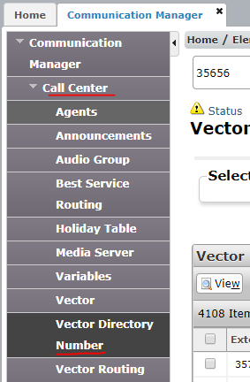

1. Make sure to select ONLY the node you need to export. Click Show List button once node is checked.

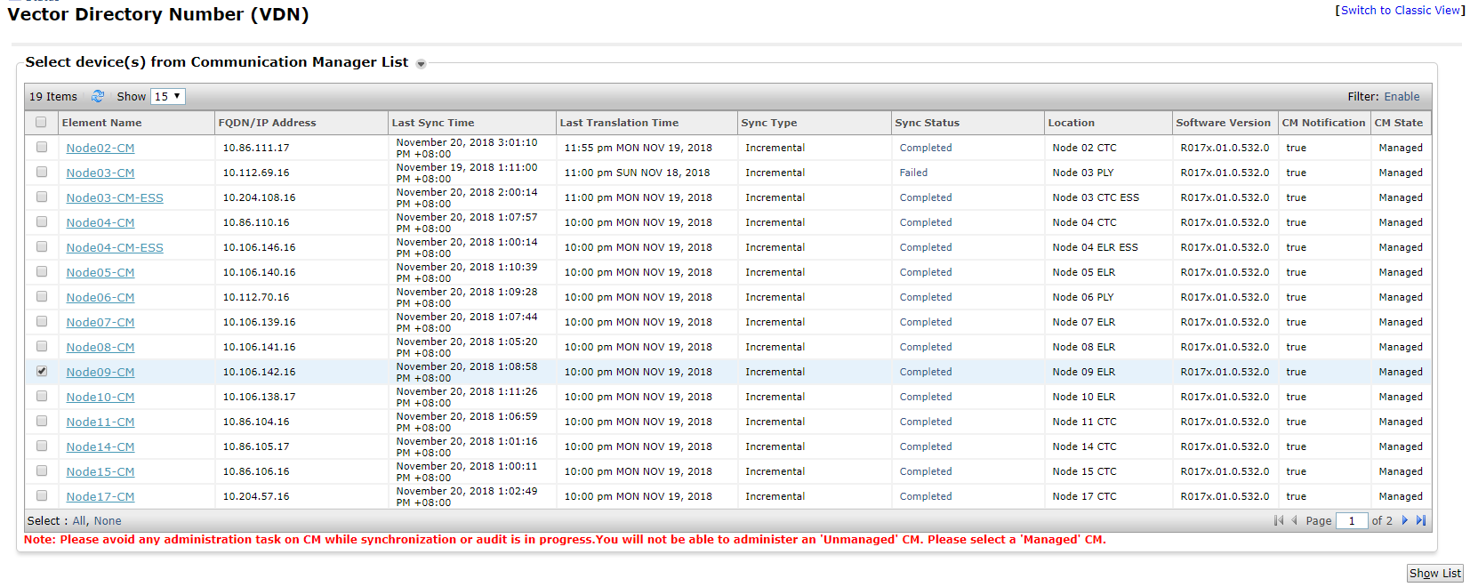

1. Click on More Actions dropdown and click the “Export All VDN”

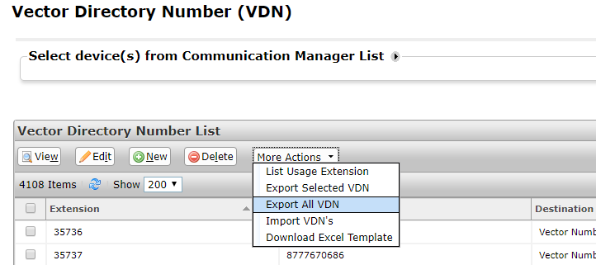

1. On the Schedule, you can choose Run immediately or Schedule the export. Click the Export button to proceed.

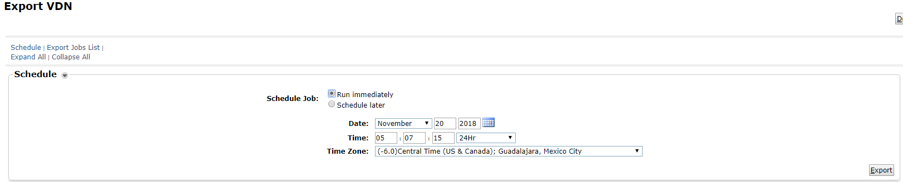

1. On the Export Job List, click the refresh icon to update the status of your export.

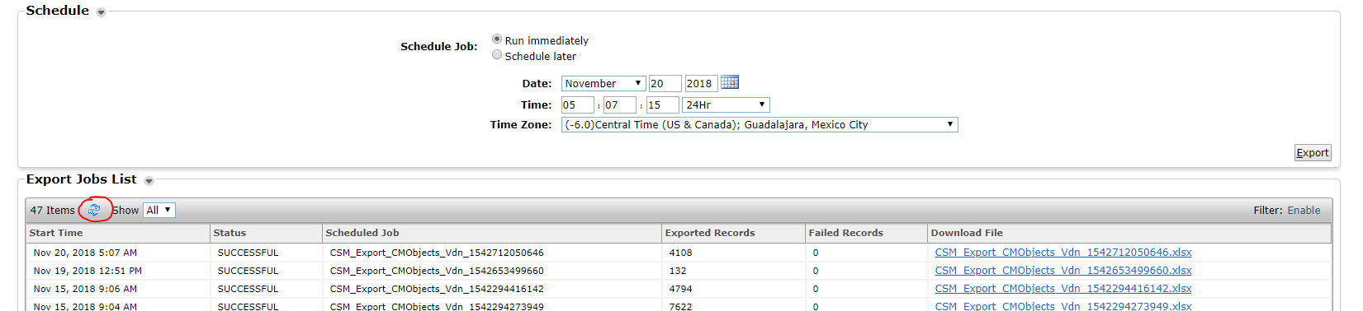

1. Excel file will be available once export is successful. Click on the link to download the excel file.

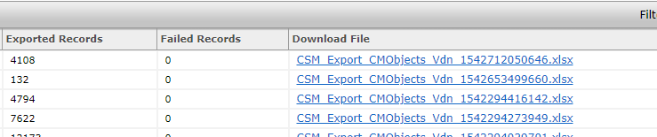

1. Exported VDNs look like the list below:

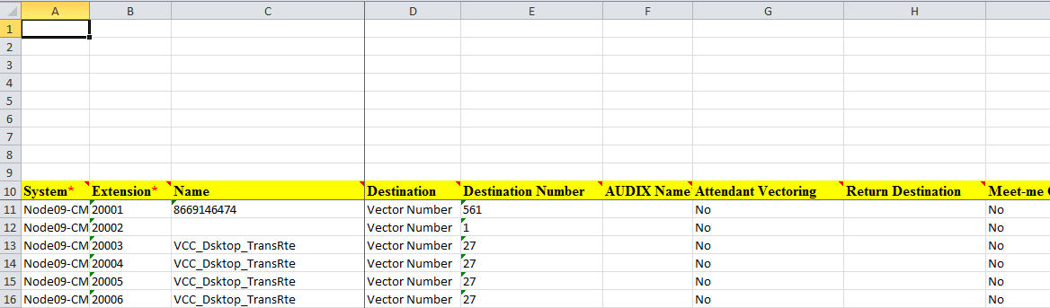

**Bulk Import**

1. Download VDN template for bulk import. VDN template looks like this:

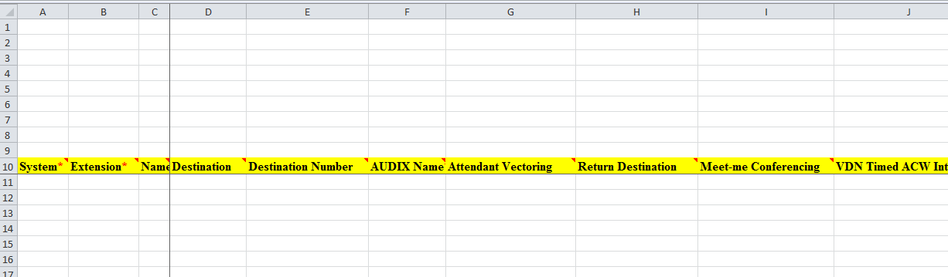

1. Copy the VDNs from the exported file to the template. If you want to update a field, make sure to put apostrophe (‘) for any number field. Number input is invalid during import.

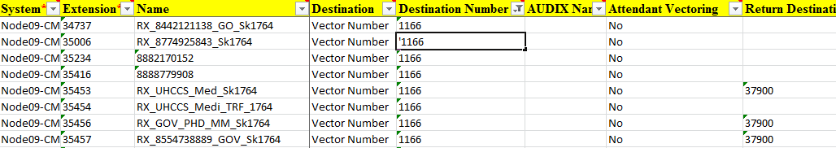

1. On the Communication Manager. Go to Call Center > Vector Directory Number



1. Make sure to select ONLY the node you need to export. Click Show List button once node is checked.



1. Click on More Actions dropdown and click the “Import VDN’s”

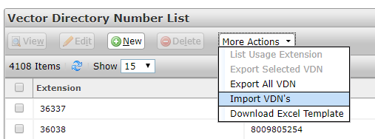

1. On the Import CM Objects page, browse the file you want to import on the File Selection pane.

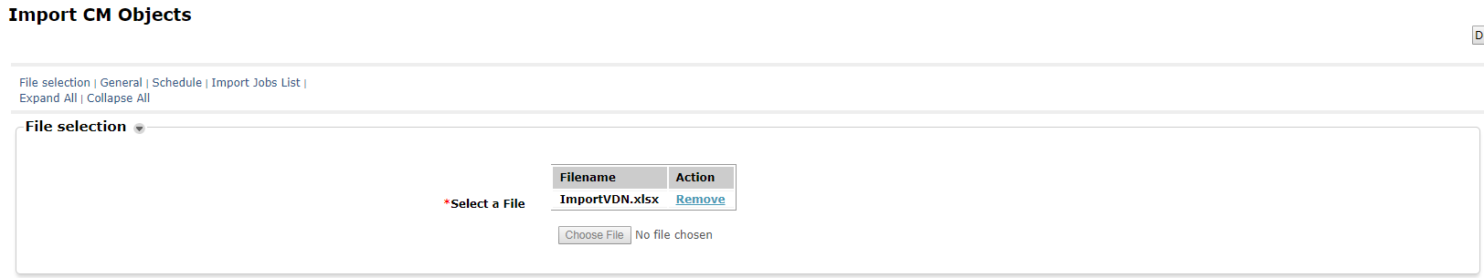

1. On the General pane,
   1. Select Error Configuration – choose how you want failed import to be treated. “Abort on First Error” means the import will stop after encountering the first error while the “Continue processing other records” means the import will continue up to the last list.
   2. If a matching record already exists – this is important to whether you are importing new record, deleting or updating VDNs. “Skip” means if the same extension number is encountered, your record for that VDN will not be imported, “Merge” means if the same extension number is encountered, your record will overwrite the existing record, “Delete” means if the same extension number is encountered, the existing record will be deleted.

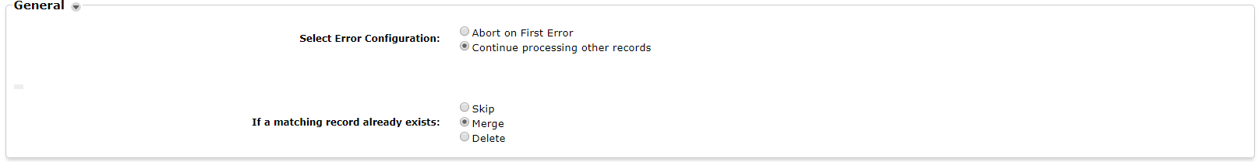

1. On the Schedule pane, you can choose Run immediately or Schedule the import. Click the Import button to proceed.

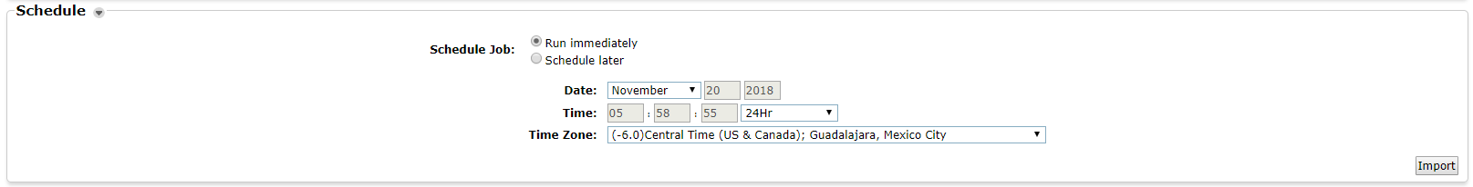

1. On the Import Job List, click the refresh icon to update the status of the import.

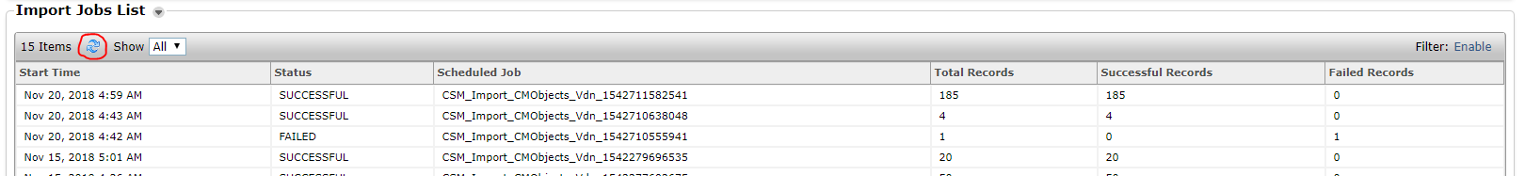

**Download Audio Files of PBX Announcements**

1. On the Communication Manager. Go to Call Center > Announcements

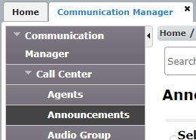

1. Make sure to select ONLY the node you need to export. Click Show List button once node is checked.



1. Click on More Actions dropdown and click the “Backup All”. You can only download the audio file using Backup All function.

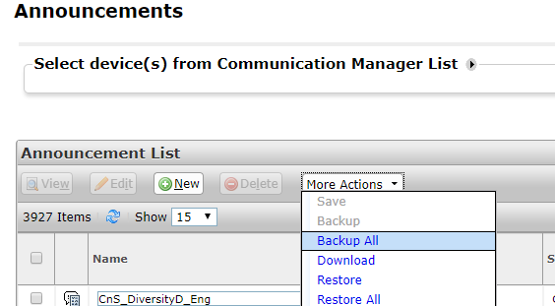

1. On the next page, click Backup Wave Files. Click Backup button to proceed.

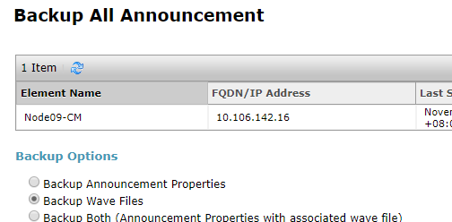

NOTE: Backup will take some time, but closing the browser will not affect the backup process.

1. To check if files have been backed up successfully, go to More Actions > Download. You will be able to see your backup if it is already available.

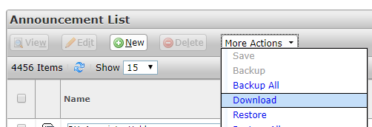

1. Click on the Backup you made, the name of the backup file would look like this:

Backupname_node#_day_month_year_time

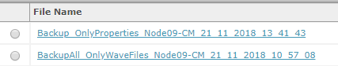

1. Backup_OnlyProperties – if you backup only the properties/ information of the wav file
2. BackupAll_OnlyWaveFiles – if you backup only the wav files
3. Backup_Both – if you backup both properties and wav files

Click the “Download” button to proceed with the download.

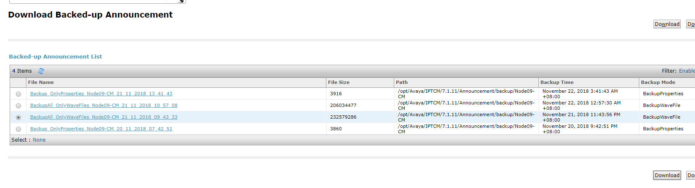

1. Your download will be in a zip format. Before extracting, create a new folder to where you are going to extract the file. Extract the file, all board folders together with the wav files will be available.



